Experiment no:

AIM:

smart home using iot

REQUIREMENTS:

1. home gateway

2.ceiling fan

3.window

4.smart phone

5.packwt Tracer software

Procedure:

STEP 1: firstly. place the home gateway and from home drag and drop a ceiling fan and a window

step 2 : from tools click the draw pallets and choose rectangle shape from it and insert the fan and window inside it

STEP 3: config each and cjnage their respective display names.

step 4 : now connect the home gateway to the fan and the home gateway to the window also.after this place a smart phone and establish the connection between the two.

STEP 5: check all the connections and verify

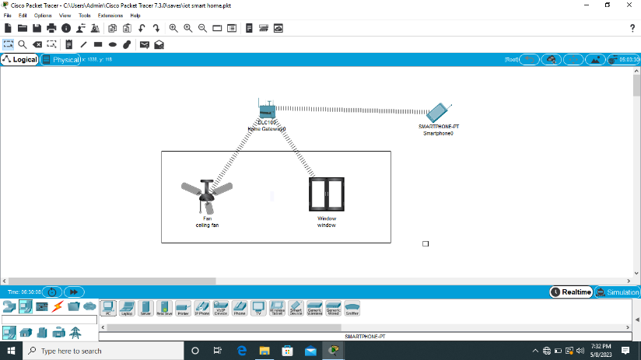

result : the configuration of a smart home using iot is completed and verified successfully